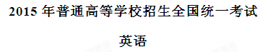
本试卷分第Ⅰ卷和第Ⅱ卷两部分，共12页。满分150分。考试用时120分钟。考试结束后，将本试卷和答题卡一并交回。
注意事项：
1. 答题前，考生务必用0.5毫米黑色签字笔将自己的姓名、座号、考生号、县区和科类填写在答题卡和试卷规定的位置上。
2. 第Ⅰ卷每小题选出答案后，用2B铅笔把答题卡上对应题目的答案标号涂黑；如需改动，用橡皮擦干净后，再选涂其他答案标号。
3. 第Ⅱ卷必须用0.5毫米黑色签字笔作答，答案必须写作答题卡各题目指定区域内相应的位置，不能写在试卷上；如需改动，先划掉原来的答案，然后再写上新的答案；不能使用涂改液、胶带纸、修正带。不按以上要求作答的答案无效。
第Ⅰ卷
第一部分听力（共两节，满分 30 分）
做题时，先将答案标在试卷上，录音内容结束后，你将有两分钟的时间将试卷上的答案转涂到答
题卡上。
第一节（共 5 小题；每小题 1.5 分，满分 7.5 分）
听下面 5 段对话，每段对话后有一个小题。从题中所给的 A、B、C 三个选项中选出最佳选项，并标
在试卷的相应位置。听完每段对话后，你都有 10 秒钟的时间来回答有关小题和阅读下一小题。每段对
话仅读一遍。
例： How much is the shirt?
A.£ 19.15 B.£ 9.18 C.£ 9.15
- 答案是 C。
- What time is it now?
A.9:10 B.9:50 C.10:00
2. What does the woman think of the weather?
A. It’s nice B. It’s warm C. It’s cold
3. What will the man do?
A. Attend a meeting B. Give a lecture C. Leave his office
4. What is the woman’s opinion about the course?
A. Too hard B. Worth taking C. Very easy
5. What does the woman want the man to do?
A. Speak louder. B. Apologize to her C. Turn off the radio
第二节（共15小题；每小题1.5分，满分22.5分）
听下面5段对话或独白。每段对话或独白后有几个小题，从题中所给的A、B、C三个选项中选出最佳选项，并标在试卷的相应位置。听每段对话或独白前，你将有时间阅读各个小题，每小题5秒钟；听完后，各小题将给出5秒钟的作答时间。每段对话或独白读两遍。
听第6段材料，回答第6、7题。
6. How long did Michael stay in China?
A. Five days B. One week C. Two weeks
7. Where did Michael go last year?
A. Russia B. Norway. C. India
听第7段材料，回答第8、9题。
8. What food does Sally like?
A. Chicken B. Fish C. Eggs
9. What are the speakers going to do?
A. Cook dinner B. Go shopping C. Order dishes.
听第8段材料，回答第10至12题。
10. Where are the speakers?
A. In a hospital B. In the office C. At home
11. When is the report due?
A. Thursday B. Friday C. Next Monday.
12. What does George suggest Stephanie do with the report?
A. Improve it.
B. Hand it in later.
C. Leave it with him.
听第9段材料，回答第13至16题。
13.What is the probable relationship between the speakers?
A. Salesperson and customer.
B. Homeowner and cleaner.
C. Husband and wife.
14.What kind of apartment do the speakers prefer？
A. One with two bedrooms.
B. One without furniture
C. One near a market
15. How much rent should one pay for the one-bedroom apartment?
A. $300. B. $400 C. $415
16. Where is the apartment the speakers would like to see?
A. On Lake Street B. On Market Street C. On South Street.
听第10段材料，回答第17至20题。
17.What percentage of the world’s tea exports go to Britain?
A. Almost 15% B. About 30% C. Over 40%
18.Why do tea taster taste tea with milk?
A. Most British people drink tea that way.
B. Tea tastes much better with milk.
C. Tea with milk is healthy.
19. Who suggests a price for each tea?
A. Tea tasters.
B. Tea exporters.
C. Tea companies.
20. What is the speaker talking about?
A. The life of tea tasters.
B. Afternoon tea in Britain.
C. The London Tea Trade Centre.
第二部分阅读理解（共两节，满分40分）
- （共15小题；每小题2分，满分30分）
阅读下列短文，从每题所给的四个选项（A、B、C、和D）中，选出最佳选项，并在答题卡上将该项涂黑。
A
Monthly Talks at London Canal Museum
Our monthly talks start at 19:30 on the first Thursday of each month except August. Admission is at normal charges and you don’t need to book. They end around 21:00.
November 7th
The Canal Pioneers, by Chris Lewis. James Brindley is recognized as one of the leading early canal engineers. He was also a major player in training others in the art of canal planning and building. Chris Lewis will explain how Brindley made such a positive contribution to the education of that group of early “civil engineers”.
December 5th
Ice for the Metropolis, by Malcolm Tucker. Well before the arrival of freezers, there was a demand for ice for food preservation and catering, Malcolm will explain the history of importing natural ice and the technology of building ice wells, and how London’s ice trade grew.
February 6th
An Update on the Cotsword Canals, by Liz Payne. The Stroudwater Canal is moving towards reopening. The Thames and Severn Canal will take a little longer. We will have a report on the present state of play.
March 6th
Eyots and Aits -Thames Islands, by Miranda Vickers. The Thames has many islands. Miranda has undertaken a review of all of them. She will tell us about those of greatest interest.
Online bookings:www.canalmuseum.org.uk/book
More info: www.canalmuseum.org.uk/whatson
London Canal Museum
12-13 New Wharf Road, London NI 9RT
www.canalmuseum.org.ukwww.canalmuseum.mobi
Tel:020 77130836
21.When is the talk on James Brindley?
A. February 6th.
B. March 6th.
C. November 7th.
D. December 5th.
22. What is the topic of the talk in February?
A. The Canal Pioneers.
B. Ice for the Metropolis
C. Eyots and Aits- Thames Islands
D. An Update on the Cotsword Canals
23. Who will give the talk on the islands in the Thames.
A. Miranda Vickers
B. Malcolm Tucker
C. Chris Lewis
D. Liz Payne
【答案】
21. C
22. D
23. A
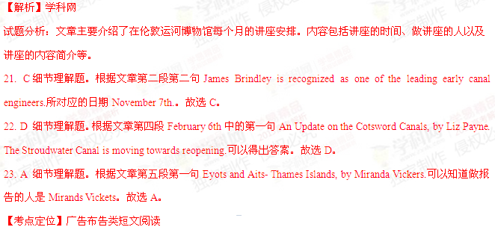【名师点睛】本篇文章是一篇应用文。文章整体阅读难度较低，所设题目均为考查细节理解题，考生只需通过关键词定位可得出答案。如21题抓住关键词“James Brindley”，22题抓住关键词“February”，23题抓住关键词“Thames”。考生做此类阅读理解时可以先从其问题着手，带着问题的关键词到原文中找出相对应的部分，然后通过对照和比较，就不难选出正确答案。
B
The freezing Northeast hasn’t been a terribly fun place to spend time this winter, so when the chance came for a weekend to Sarasota, Florida, my bags were packed before you could say “sunshine”. I left for the land of warmth and vitamin C(维生素C), thinking of beaches and orange trees. When we touched down to blue skies and warm air, I sent up a small prayer of gratefulness. Swimming pools, wine tasting, and pink sunsets(at normal evening hours, not 4 in the afternoon) filled the weekend, but the best part - particularly to my taste, dulled by months of cold- weather root vegetables- was a 7 a.m. adventure to the Sarasota farmers’ market that proved to be more than worth the early wake-up call.
The market, which was founded in 1979, sets up its tents every Saturday from 7:00 am to 1 p.m., rain or shine, along North Lemon and State streets. Baskets of perfect red strawberries; the red-painted sides of the Java Dawg coffee truck; and most of all, the tomatoes: amazing, large, soft and round red tomatoes.
Disappointed by many a broken, vine-ripened(蔓上成熟的) promise, I’ve refused to buy winter tomatoes for years. No matter how attractive they look in the store, once I get them home they’re unfailingly dry, hard, and tasteless. But I homed in, with uncertainty, on one particular table at the Brown’s Grove Farm’s stand, full of fresh and soft tomatoes the size of my fist. These were the real deal- and at that moment, I realized that the best part of Sarasota in winter was going to be eating things that back home in New York I wouldn’t be experiencing again for months.
Delighted as I was by the tomatoes in sight, my happiness deepened when I learned that Brown’s Grove Farm is one of the suppliers for Jack Dusty, a newly opened restaurant at the Sarasota Ritz Carlton, where - luckily for me - I was planning to have dinner that very night. Without even seeing the menu, I knew I’d be ordering every tomato on it.
24. What did the author think of her winter life in New York?
A. Exciting. B. Boring.
C. Relaxing. D. Annoying.
25. What made the author’s getting up late early worthwhile?
A. Having a swim.
B. Breathing in fresh air.[来源:学科网]
C. Walking in the morning sun.
D. Visiting a local farmer’s market.
26. What can we learn about tomatoes sold in New York in winter?
A. They are soft.
B. They look nice.
C. They taste great.
D. They are juicy.
27. What was the author going to that evening?
A. Go to a farm.
B. Check into a hotel.
C. Eat in a restaurant.
D. Buy fresh vegetables
【答案】
24. B
25. D
26. B
27. C
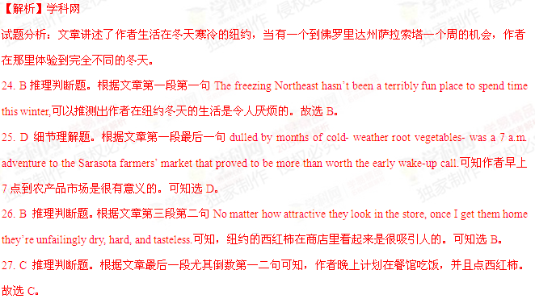【考点定位】记叙类短文阅读
【名师点睛】本文是一篇记叙类短文，整体难度中等，难度较大的是24和26题，学生容易判断错误，需要通过一定的推理才能判断正确。学生首先要从倒数第二段最后一句判断出作者原来生活在纽约，才可理解第一段第一句描述的是纽约。第26题考生是不能根据作者前面描述的文字判断，真正答案要从后段文字描述去判断。这就要求考生做此类阅读时要注意前后之间的联系与对比，选择答案时切不可以以偏概全。
C
Salvador Dali (1904-1989) was one of the most popular of modern artists. The Pompidou Centre in Paris is showing its respect and admiration for the artist and his powerful personality with an exhibition bringing together over 200 paintings, sculptures, drawings and more. Among the works and masterworks on exhibition the visitor will find the best pieces, most importantly The Persistence of Memory. There is also L’Enigme sans Fin from 1938, works on paper, objects, and projects for stage and screen and selected parts from television programmes reflecting the artist’s showman qualities.
The visitor will enter the World of Dali through an egg and is met with the beginning, the world of birth. The exhibition follows a path of time and subject with the visitor exiting through the brain.
The exhibition shows how Dali draws the viewer between two infinities (无限). “From the infinity small to the infinity large, contraction and expansion coming in and out of focus: amazing Flemish accuracy and the showy Baroque of old painting that he used in his museum-theatre in Figueras,” explains the Pompidou Centre.
The fine selection of the major works was done in close collaboration (合作)with the Museo Nacional Reina Sofia in Madrid, Spain, and with contributions from other institutions like the Salvador Dali Museum in St. Petersburg, Florida.
28. Which of the following best describe Dali according to Paragraph 1?
A. Optimistic. B. Productive. C. Generous. D. Traditional.
29. What is Dali’s The Persistence of Memory considered to be?
A. One of his masterworks.
B. A successful screen adaptation.
C. An artistic creation for the stage.
D. One of the best TV programmes.
30. How are the exhibits arranged at the World of Dali?
A. By popularity.
B. By importance.
C. By size and shape.
D. By time and subject.
31. What does the word “contributions” in the last paragraph refer to?
A. Artworks. B. Projects. C. Donations. D. Documents.
【答案】
28. B
29. A
30. D
31. A
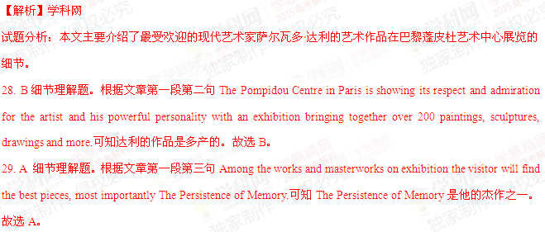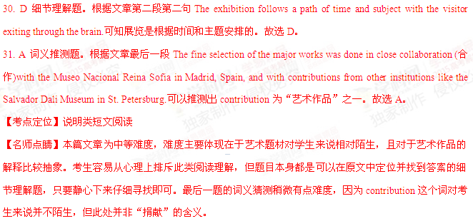

D
Conflict is on the menu tonight at the café La Chope. This evening, as on every Thursday night, psychologist Maud Lehanne is leading two of France’s favorite pastimes, coffee drinking and the “talking cure”. Here they are learning to get in touch with their true feelings. It isn’t always easy. They customers - some thirty Parisians who pay just under $2 (plus drinks) per session - care quick to intellectualize (高谈阔论)，slow to open up and connect. “You are forbidden to say ‘one feels,’ or ‘people think’,” Lehane told them. “Say ‘I think,’ ‘Think me’.”
A café society where no intellectualizing is allowed? It couldn’t seem more un-French. But Lehanne’s psychology café is about more than knowing oneself: It’s trying to help the city’s troubled neighborhood cafes. Over the years, Parisian cafes have fallen victim to changes in the French lifestyle - longer working hours, a fast food boom and a younger generation’s desire to spend more time at home. Dozens of new theme cafes appear to change the situation. Cafes focused around psychology, history, and engineering are catching on, filling tables well into the evening.
The city’s psychology cafes, which offer great comfort, are among the most popular places. Middle-aged homemakers, retirees, and the unemployed come to such cafes to talk about love, anger, and dreams with a psychologist. And they come to Lehanne’s group just to learn to say what they feel. “There’s a strong need in Paris for communication,” says Maurice Frisch, a cafe La Chope regular who works as a religious instructor in a nearby church. “People have few real friends. And they need to open up.” Lehanne says she’d like to see psychology cafes all over France. “If people had normal lives, these cafes wouldn’t exist”, she says, “If life weren’t a battle, people wouldn’t need a special place just to speak.” But them, it wouldn’t be France.
32.What are people encouraged to do at the cafe La Chope?
A. Learn a new subject
B. Keep in touch with friends.
C. Show off their knowledge.
D. Express their true feelings.
33. How are cafes affected by French lifestyle changes?
A. They are less frequently visited.
B. They stay open for longer hours.
C. They have bigger night crowds.
D. They start to serve fast food.
34. What are theme cafes expected to do?
A. Create more jobs.
B. Supply better drinks.
C. Save the cafe business.
D. Serve the neighborhood.
35. Why are psychology cafes becoming popular in Paris?
A. They bring people true friendship.
B. They give people spiritual support.
C. They help people realize their dreams.
D. They offer a platform for business links.
【答案】
32. D
33. A
34. C
35. B
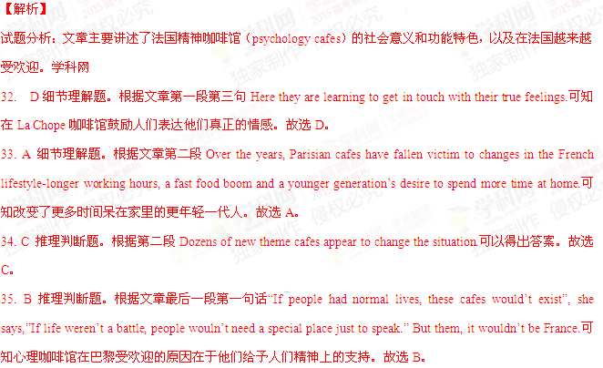【考点定位】社会类短文阅读
【名师点睛】这是一篇社会类短文阅读。难度中等偏上，学生不易读懂。但是第32和33题均为考查细节理解题，问题设计比较简单，考生只需通过关键词定位即可得出答案。其中第34和35题需要在原文的内容的基础之上作出推理，才能判断出正确的答案。考生做此类阅读时要注意前后之间的联系与对比，选择答案时切不可以以偏概全。
第二节（共5小题，每小题2分，满分10分）
根据短文内容，从短文后的选项中选出能填入空白处的最佳选项，选项中有两项为多余选项。
Building Trust in a Relationship Again
Trust is a learned behavior that we gain from past experiences, 36 .Trust is a risk. But you can’t be successful when there’s a lack of trust in a relationship that results from an action where the wrongdoer takes no responsibility to fix the mistake.
Unfortunately, we’ve all been victims of betrayal. Whether we’ve been stolen from, lied to , misled, or cheated on, there are different levels of losing trust. Sometimes people simply can’t trust anymore, 37. It’s understandable, but if you’re willing to build trust in a relationship again, we have some steps you can take to get you there.
- 38 having confidence in yourself will help you make better choices because you can see what the best outcome would be for your well-being.
- 39 If you’ve been betrayed, you are the victim of your circumstance. But there’s a difference between being a victim and living with a “victim mentality”. At some point in all of our lives, we’ll have our trust tested or violated.
- You didn’t lose “everything”. Once trust is lost, what is left? Instead of looking at the situation from this hopeless angle, look at everything you still have and be thankful for all of the good in your life. 40 instead, it’s a healthy way to work through the experience to allow room for positive growth and forgiveness.
  - Learn to really trust yourself.
  - It is putting confidence in someone.
  - Stop regarding yourself as the victim.
  - Remember that you can expect the best in return.
  - They’ve been too badly hurt and they can’t bear to let it happen again.
  - This knowledge carries over in their attitude toward their future relationships.
  - Seeing the positive side of things doesn’t mean you’re ignoring what happened.
【答案】
36. B
37. E
38. A
39. C
40. G
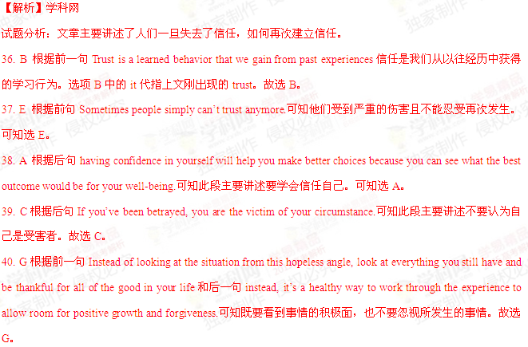【考点定位】议论类短文阅读
【名师点睛】本篇阅读填空题延续了一贯的总分式结构，难度总体适中。第36题主要考查顺承上文，第37题考查前面句的因果关系，第38、39题考查总分关系，第40题考查转折关系。考生解题时一定首先理解文章大意，然后在做题时分析前后句之间的关系，最后要将所选的答案带回原文当中阅读，最终才能选择正确答案。
第三部分英语知识运用（共两节，满分45）
- 完形填空（共20小题；每小题15分，满分30分）
阅读下面短文，从短文后各题所给的四个选项（A、B、C和D）中，选出可以填入空白处的最佳选项，并在答题卡上将该项涂黑。
My kids and I were heading into the supermarket over the weekend. On the way, we spotted a man holding a piece of paper that said, “ __41___ my job. Family to Feed.”[来源:Zxxk.Com]
At this store, a __42___ like this is not normal. My 10-year-old noticed him and make a __43____ on how bad it must be to have to stand ___44____ in the cold wind.
In the store, I asked each of my kids to __45___ something they thought our “friend” there would ___46___. They got apples, a sandwich and a bottle of juice. Then my 17-year-old suggested giving him a ___47____. I thought about it. We were ___48__ on cash ourselves, but… well, sometimes __49___ from our need instead of our abundance is ___50__ what we need to do! All the kids __51____ something they could do away with for the week.
When we handed him the bag of __52__, he lit up and thanked us with ___53__ eyes. When I handed him the gift card, saying he could use it for __54____his family might need, he burst into tears.
This has been a wonderful ___55__ for our family. For days the kids have been looking for others we can __56___! Things would have played out so __57____ if I had simply said, “No, we really don’t have ___58___ to give more.” Stepping out not only helped a brother in __59___, it also gave my kids the __60____ taste of helping others. It’ll go a long way with them.
41. A. Lost B. Changed C. Quit D. Finished
42. A condition B. place C. sight D. show
43. A. suggestion B. comment C. decision D. call[来源:学科网]
44. A. outside B. proudly C. by D. angrily
45. A. draw B. say C. arrange D. pick
46. A. order B. supply C. appreciate D. discover
47. A. dollar B. job C. hot meal D. gift card
48. A. easy B. low C. soft D. loose
49. A. giving B. saving C. spending D. begging
50. A. yet B. even C. still D. just
51. A. declared B. shared C. ignored D. expected
52. A . toys B. medicine C. food D. clothes
53. A. sleepy B. watery C. curious D. sharp
54. A. whoever B. whatever C. whichever D. whenever
55. A. experience B. example C. message D. adventure
56. A. rely on B. respect C. learn from D. help
57. A. suddenly B. vividly C. differently D. perfectly
58. A. time B. power C. patience D. money
59. A. fear B. love C. need D. memory
60. A. strong B. sweet C. strange D. simple
【答案】
41. A42. C43. B44. A45. D46. C47. D48. B49. A50. D51. A52. C53. B54. B55. A56. D57. C58. D59. C60. B
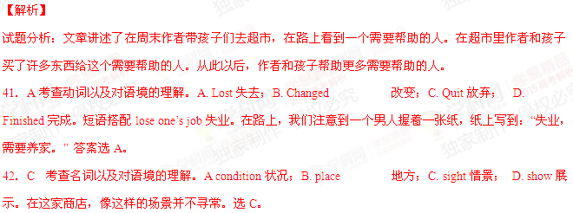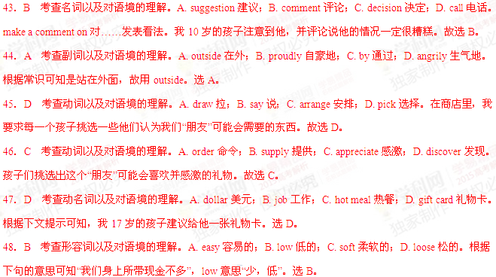49．A 考查动词以及对语境的理解。A. giving给予；B. saving节省；C. spending 花费；D. begging恳求。有的时候，给予是我们需要做些什么，而不是在于我们给予多少。选A。
50．D 考查副词以及对语境的理解。A. yet然而；B. even甚至；C. still任然；D. just刚刚。仅仅是我们需要做些什么。选D。
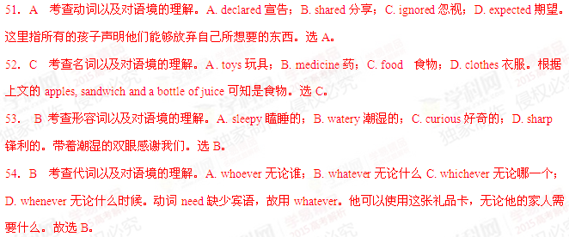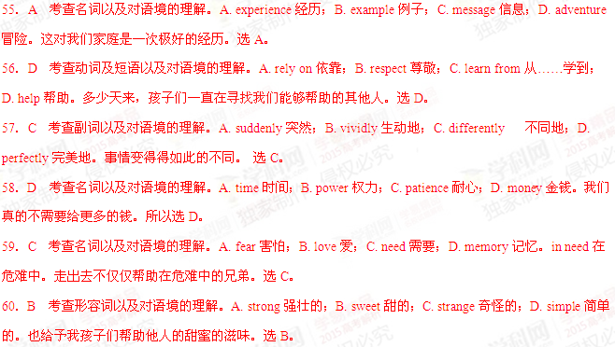【考点定位】记叙类短文阅读。
【名师点睛】本文是一篇记叙类的完形填空，难度中等偏易。考查侧重对文章的理解，少量考查语法结构，如54题。有难度的有48题、51题和60题，需要联系上下文进一步理解，才能做出正确的判断。考生做题时需要理解文章大意，特别注重语境的理解，前后句之间的联系，在语境中斟酌所选的答案。最后再将所选好的答案带到原文当中，将整个文章再读一遍，才能保证答案的准确性。
第II卷
注意事项：
用0.5毫米黑色签字笔将答案写在答题卡。写在本试卷上无效。[来源:Zxxk.Com]
第三部分英语知识运用（共两节满分45）
- （共10小题：每小题1.5分，满分15分）
阅读下面材料，在空白处填入适当的内容（1个单词）或括号内单词的正确形式。将答案填写在答题卡的相应位置。
Yangshuo, China
It was raining lightly when I__61__(arrive) in Yangshuo just before dawn. But I didn’t care. A few hours__62__, I’d been at home in Hong Kong, with __63_ (it) choking smog. Here, the air was clean and fresh, even with the rain.
I’d skipped nearby Guilin, a dream place for tourists seeking the limestone mountain tops and dark waters of the Li River_64__are pictured by artists in so many Chinese _65__(painting). Instead, I’d headed straight for Yangshuo. For those who fly to Guilin, it’s only an hour away__66_ car and offers all the scenery of the better-known city.
Yangshuo__67__(be) really beautiful. A study of travelers _68__(conduct) by the website TripAdvisor names Yangshuo as one of the top 10 destinations in the world. And the town is fast becoming a popular weekend destination for people in Asia. Abercrombie & Kent, a travel company in Hong Kong, says it __69_ (regular) arranges quick getaways here for people _70__(live) in Shanghai and Hong Kong.
【答案】
61.arrived
62. before/earlier
63. its
64.that/which
65. paintings
66.by
67. is
68. conducted
69. regularly
70. living
【解析】
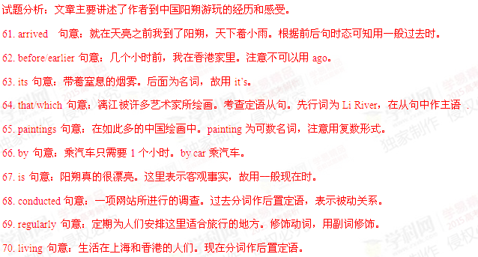【考点定位】语法填空。
【名师点睛】本文是一篇游记，难度较易。侧重对语法知识的考查，特别注重时态、名词单复数、介词、副词、非谓语动词以及定语从句等的考查。考生解此类题型时首先理解文章大意，然后判断文章的整体时态，最后根据各空来判断所考查的语法点，依据所学语法写出正确答案。做完之后再整体阅读全文对所填写的答案进行复查。
第四部分写作（共两节满分35分）
- 短文改错（共10小题；每小题1分，满分10分）
假定英语课上老师要求同桌之问交换修改作文，请你修改你同桌写的以下作文。文中共有10处语言错误，每句中最多有两处。每处错误仅涉及一个单词的增加、删除或修改。
增加：在缺词处加一个漏字符号(∧)，并在其下面写出该加的词。
删除：把多余的词用斜线( \ )划掉。
修改：在错的词下画一横线，并在该词下面写出修改后的词。
注意：1．每处错误及其修改均仅限一词；
2．只允许修改10处，多者(从第11处起)不计分。
When I was a child, I hoped to live in the city. I think I would be happy there. Now I am living in a city, but I miss my home in countryside. There the air is clean or the mountains are green. Unfortunately, on the development of industrialization, the environment has been polluted. Lots of studies have been shown that global warming has already become a very seriously problem. The airs we breathe in is getting dirtier and dirtier. Much rare animals are dying out . We must found ways to protect your environment. If we fail to do so ,we’ll live to regret it .
【答案】
76. think –thought
77. countryside前加the
78. or—and
79. on—with
80. been去掉[来源:学科网]
81. seriously—serious
82. airs—air
83. much—many
84. found—find
85. your—our
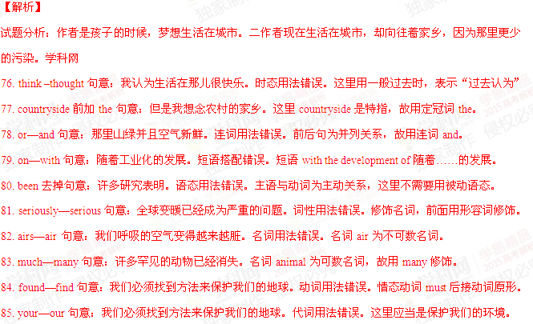【考点定位】短文改错。
【名师点睛】改错题整体难度适中，文章简单易懂。考点分布均匀，添、删、改比例为1:1:8。重点考查时态、名词的单复数、冠词、连词、副词以及介词的搭配等。考生解此类题型时一般应遵循保持句子原意的原则，即不能改变文章或作者所表达的意思，包括其语气和上下文的逻辑关系。只对短文中的用词错误、语法错误、行文关系错误进行改正，且要小改而不大改。
- 书面表达（满分25分）
假定你是李华，你校英文报“外国文化”栏目拟刊登介绍美国节日风俗和中学生生活的短文。请给美国朋友彼得写信约稿，要点如下：
- 栏目介绍；
- 稿件内容；
- 稿件长度：约400词；
- 交稿日期：6月28日前。
注意：
- 词数100左右；
- 可以适当增加细节，以使行文连贯的；
- 开头语已为你写好。
【答案】
Dear Peter,
I'd like to ask you to write an article for our school’s English newspaper.
The “Foreign Cultures” section in our newspaper is very popular among us students. It carries articles written by foreign friends about the cultures of their home countries. Would you please write something about the culture in your part of the United States? And we would especially welcome articles about how Americans spend their holidays and festivals, and the life of American high school students. You can write anything relevant so long as it’s interesting and informative. 400 words would be fine. Could we have your article before June 28?
I’m looking forward to hearing from you.
Yours,
Li Hua
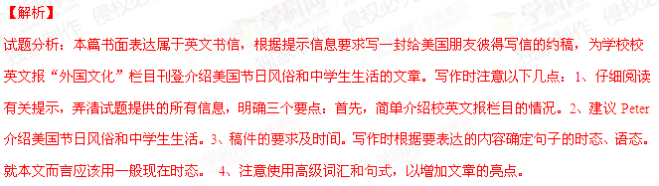【亮点说明】本文结构紧凑，层次分明，而且使用了多种句式和结构。比如It carries articles written by foreign 